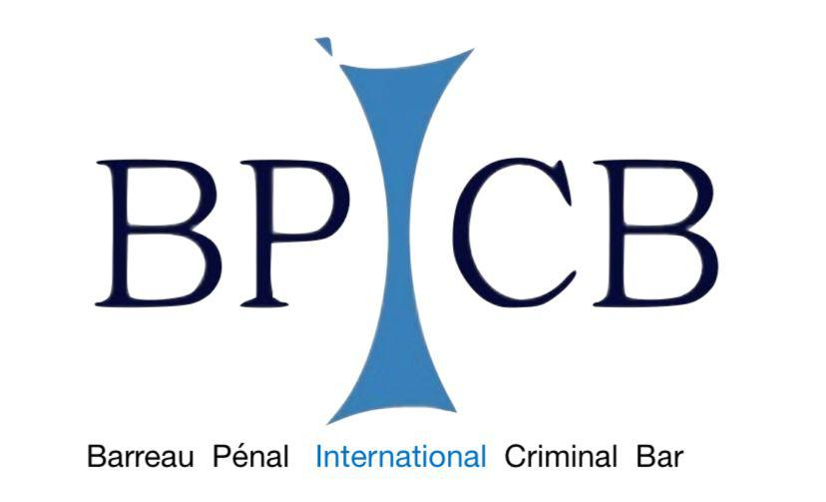

UNIVERSITIES NETWORK FOR CHILDREN IN ARMED CONFLICT

ADVANCED TRAINING COURSE
INTERNATIONAL CRIMINAL JURISDICTION INVOLVING CHILDREN IN ARMED CONFLICT
Procedural and deontological profiles concerning the role of lawyers
June 8th , 2022-October 20th,2022

SECOND MODULE (CONTINUATION)
THE ROLE OF LAWYERS BEFORE THE ICC IN CASES INVOLVING CHILDREN AFFECTED BY ARMED CONFLICTS

14 September 2022

Seventh Day: Crimes within the ICC’s jurisdiction against or affecting children.
This lesson will analyze the elements of the crimes under the Rome Statute targeting and/or affecting children.

7.1. Conscription, enlistment, and use of children under the age of 15 years to participate actively in hostilities, as war crimes in violation of Articles 8(2)(b)(xxvi) and 8(2)(e)(vii) of the Rome Statute.
Forcible transfer of children and prevention of birth, as acts of genocide in violation of Articles 6(d) and 6(e) of the Rome Statute.
7.2. Trafficking of children as a form of enslavement constituting a crime against humanity in violation of Articles 7(1)(c) and 7(2)(c) of the Rome Statute.
Attacks on buildings dedicated to education and health care, as war crimes in violation of Articles 8(2)(b)(ix) and 8(2)(e)(iv) of the Rome Statute.
7.3. Torture and related war crimes and crimes against humanity, in violation of Articles 7(1)(f), 7(1)(k), 8(2)(a)(ii), 8(2)(a)(iii) and 8(2)(c)(ii) of the Rome Statute.
7.4. Persecution as a crime against humanity, in violation of Article 7(1)(h) of the Rome Statute; and
7.5. Sexual and gender-based violence as war crimes and crimes against humanity, in violation of Articles 7(1)(g), 8(2)(b)(xxii) and 8(2)(e)(vi) of the Rome Statute.

15 September 2022

Eight Day: The participation of victims before the ICC
This lesson will examine how the ICC allows individuals who have suffered harm as a result of any crime within its jurisdiction to participate as victims in the proceedings.

8.1. The innovative feature of the Rome Statute: victims’ participation in ICC proceedings
8.2. Victims’ access to the Court
8.3. Participatory regime under article 68(3) Rome Statute
8.4 Challenges

21 September 2022

Ninth Day: The legal framework for Counsel before the ICC.
This lesson will present the legal framework governing the intervention of Counsel before the ICC, analyzing the applicable legal provisions and the legal aid system.

9.1. Regulatory framework for Counsel before the ICC.
9.2. The Code of Professional Conduct for Counsel appearing before the ICC.
9.3. The legal aid system before the ICC.

22 September 2022

Tenth Day: The different role of Counsel before the ICC.
This lesson will focus on the different role that Counsel may play in ICC proceedings and the role and mandate of the Office of Public Counsel for Victims (OPCV), with the duty to ensure effective participation of victims in the proceedings, and the Office of Public Counsel for the Defence (OPCD), which provides support and substantive legal assistance to Defence’s teams.

10.1. Counsel for the Defence.
10.2. Legal Representatives of Victims.
10.3. The Office of Public Counsel for Victims (OPCV) and the Office of Public Counsel for the Defence (OPCD).

28 September 2022

Eleventh Day: Investigation and collection of evidence concerning and from children.
This lesson will focus on the technical and psychological approach that Counsel should adopt when collecting information and/or undertaking investigation involving children and how to ensure the well-being of children in the process.

11.1. Investigation and collection of information and evidence from children.
11.2. Methodologies of investigation and cooperation with national stakeholders.
11.3. Methodologies of interviewing children.

29 September 2022

Twelfth Day: Simulation

5 October 2022

Thirteenth Day: The role of Counsel assisting children in ICC proceedings.
This lesson will analyze the different aspects related to the legal assistance provided by Counsel representing children in ICC proceedings.

13.2. Presentation of views and concerns during the proceedings.
13.2. The questioning of children during the proceeding.
13.3. Reparations proceedings.

6 October 2022
Fourteenth Day: Simulation.

12 October 2022
Fifteenth Day: Analysis of ICC Case Law

13 October 2022
Sixteenth Day: Analysis of ICC Case Law

19 October 2022
Seventeenth Day: Final Exam.

Eighteenth Day: Conference DATE TO BE CONFIRMED

Responsable of the Course: Tutors:

Laura Guercio Simona Lanzellotto and Giovanna Gnerre

Secretariat: Media and Communication

Cecilia Senesi Elena Rossi
Arianna Visani Chiara Giuria
Cecilia Senesi

Scientific Committee
Laura Guercio, Fausto Pocar
Paolina Massidda

